Hanan Majeed

CMS : 519166

FUNDAMENTAL OF COMPUTER PROGRAMMING (LAB 08)

TASK A:

Write down the following code in your source file and call the function in the main function to display the output.

|  |
| --- |
| #include<iostream>  using namespace std;  //Function Definition  void area()  {  float area;  float radius;  cout << "Enter the radius: ";  cin >> radius;  area = 3.14 * radius * radius;  cout << "Area of Circle = " << area;  }  int main()  {  //call the above function in main  } |

OUTPUT:

1. Rewrite the program by moving the definition of the function area() after the main program. What other changes do you have to provide in your code to give the same output as before? Show the latest code of the program with changes highlighted by comments.

INPUT:

OUTPUT:

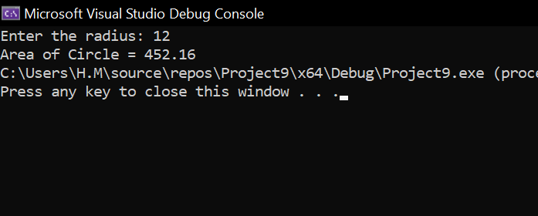

**Task B:**

Rewrite the program developed in Task A by taking the value of the radius from the user inside the main() function and **passing it by value** into the function call. Similarly, the output should be returned to the main() function to be displayed. What changes do you have to make to the function prototype, definition, and call in your code to give the same output as before? Show the latest code of the program with changes highlighted by comments.

INPUT:

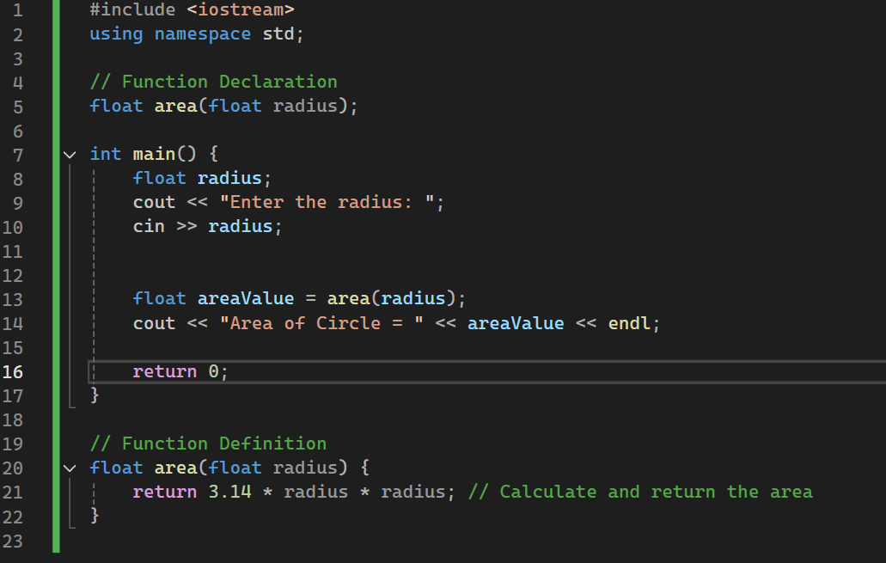

OUTPUT:

**Task C:**

Rewrite the program developed in Task B such that the arguments (actual parameters) are **passed by reference** into the call of the area() function and the return type is void. What changes do you have to make to the function prototype, definition, and call in your code to give the same output as before? Show the latest code of the program with changes highlighted by comments.

INPUT:

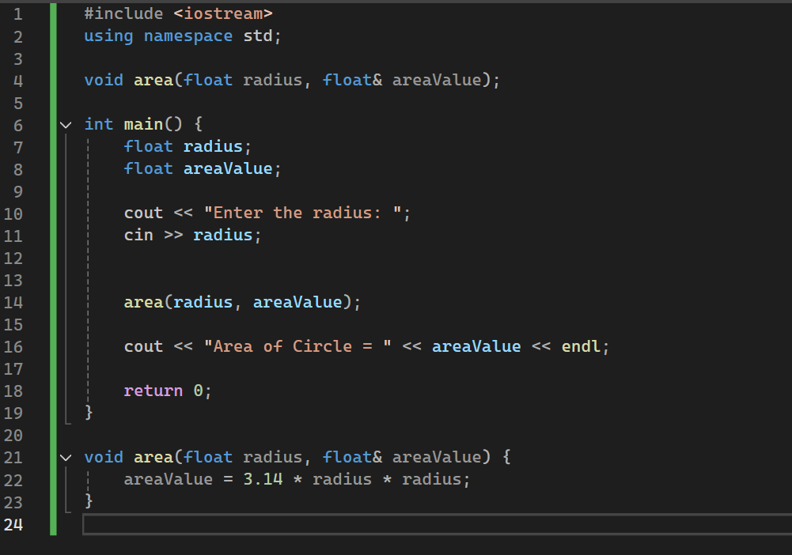

OUTPUT:

**Task D:**

Write a C++ program to compute the product of any number of integers between 2 and 5 using a single function int multiply(int, int, int, int, int). The function should use default values as parameters to allow function calls with different number of parameters. The main function should prompt the user to enter the number of integers to be multiplied and then use a switch statement to go to the respective call. Provide the definition of the multiply function after the main function.

INPUT:

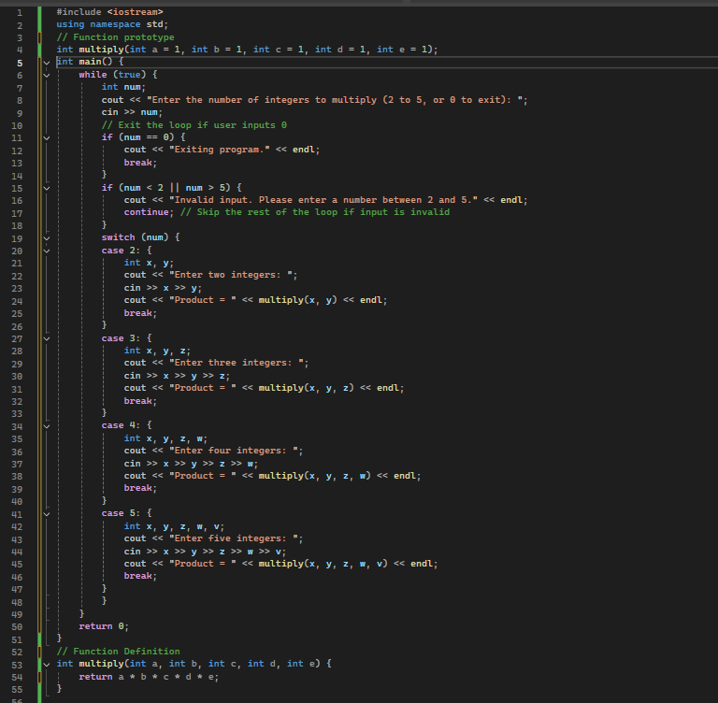

OUTPUT:

